深 圳 大 学 实 验 报 告

课程编号： 2801000049

课程名称： 机器学习

实验项目名称： Classification

学院： 电子与信息工程学院

专业： 电子信息工程

指导教师： 麦晓春

报告人： 卢嘉伟 学号： 班级： 文华

实验时间： 2025.3.31 - 2025.4.28

实验报告提交时间： 2025.4.28

教务部制
1. Experimental Purposes
(1)Familiarize with the theories and principles of classification algorithms. (2)Understand different machine learning models, including Logistic Regression, Linear Discriminant Analysis (LDA), K-Nearest Neighbors (KNN), Naive Bayes, Support Vector Machine (SVM), and Decision Tree.
(3)Learn how to preprocess data, apply classification algorithms to real datasets, evaluate model performance, and compare different classification methods using accuracy metrics.
2. Experiment Contents and Process
2.1 Experimental Contents
1.Use logistic regression to implement the classification on the Seeds dataset.
2.Use LDA to implement the classification on the Seeds dataset.
3.Use KNN to implement the classification on the Seeds dataset.
4.Use Naive Bayes classification to implement the classification on the Seeds dataset.
5.Use SVM to implement the classification on the Seeds dataset.
6.Use decision tree to implement the classification on the Seeds dataset.
2.2 Methods
1.Logistic Regression
A linear classification algorithm that models the probability of a sample belonging to a certain class using the logistic function.
Model：
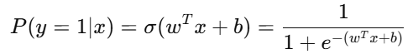
Loss Function：
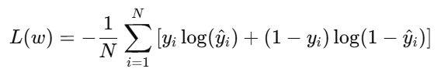
2.Linear Discriminant Analysis (LDA)
A statistical method that projects data onto a lower-dimensional space to maximize class separability.
Discriminant Function：
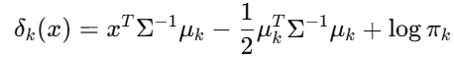
where,
μ_{k}: Mean vector of class kkk
Σ: Shared covariance matrix
π_{k}: Prior probability of class kkk
3.K-Nearest Neighbors (KNN)
A non-parametric algorithm that classifies a sample based on the majority class of its nearest neighbors.
Distance:
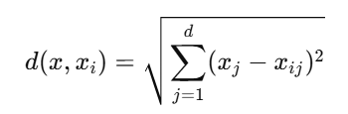
Prediction:
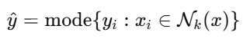
4.Naive Bayes
A probabilistic classifier based on Bayes' theorem, assuming independence between features.
Bayes Theorem:
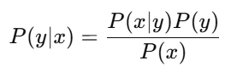
Naive Assumption:
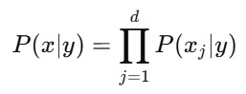
Prediction:
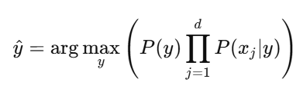
5.Support Vector Machine (SVM)
A supervised learning algorithm that finds the optimal hyperplane to separate classes in high-dimensional space.
Linear SVM Objective:
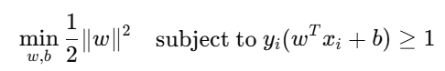
Soft Margin:
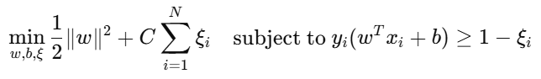
Kernel Trick:
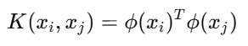
6.Decision Tree
A tree-based model that makes decisions by splitting the data based on feature values to form a hierarchical structure.
Gini Impurity:
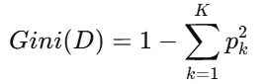
Information Gain
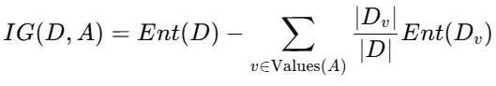
Where entropy is:
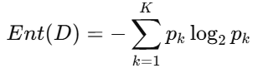
2.1.3 Data Collection, Preprocessing and Analysis
(1)Data Collection
Data source:
https://archive.ics.uci.edu/dataset/236/seeds
This database is a measurement of geometrical properties of kernels belonging to three different varieties of wheat. A soft X-ray technique and GRAINS package were used to construct all seven, real-valued attributes.
The examined group comprised kernels belonging to three different varieties of wheat: Kama, Rosa and Canadian, 70 elements each, randomly selected for the experiment. High quality visualization of the internal kernel structure was detected using a soft X-ray technique. It is non-destructive and considerably cheaper than other more sophisticated imaging techniques like scanning microscopy or laser technology. The images were recorded on 13x18 cm X-ray KODAK plates. Studies were conducted using combine harvested wheat grain originating from experimental fields, explored at the Institute of Agrophysics of the Polish Academy of Sciences in Lublin. The data set can be used for the tasks of classification and cluster analysis.
- Preprocessing&Analysis
Missing Value Analysis: Checked for null values to ensure data completeness. No missing values were found.
Train-Test Split:The dataset is split into features (X) and target labels (Y) and divided into training and test sets.Then individually create, train, and evaluate six different classification models.The dataset was divided into 80% training and 20% testing to evaluate model performance.
Performance Evaluation:Using each model, fit the model to the training data, and then use the model to predict the labels for test data. For evaluation, generate a classification report, a confusion matrix, and an accuracy score. A visual representation of the confusion matrix is offered.
2.1.4 Experimental Results and Analysis
The accuracy, classification report and confusion matrix

(1)Logistic Regression
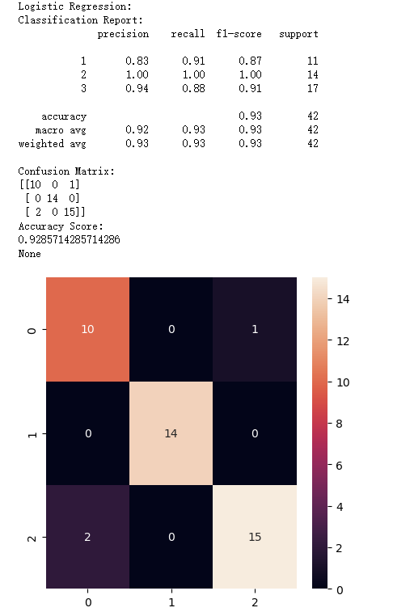
Achieved an overall accuracy of 93%
Demonstrated strong performance across all classes with balanced precision and recall
Particularly effective for class 2 (Kama wheat) with perfect precision and recall scores
Minor confusion between classes 1 and 3
(2)Linear Discriminant Analysis (LDA
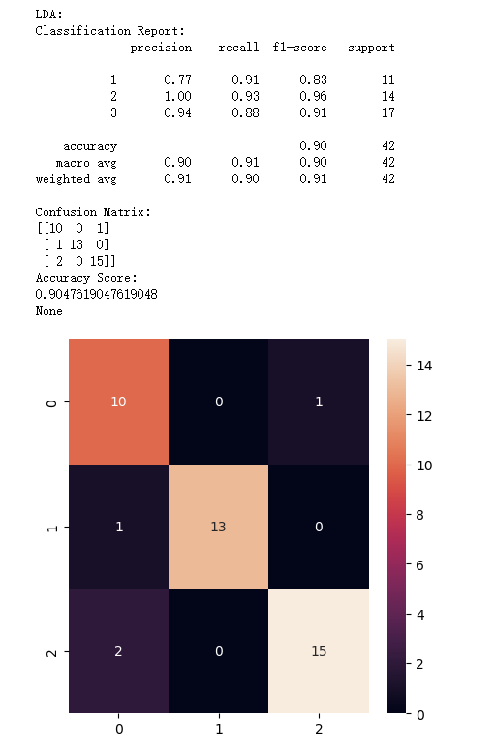
Attained an accuracy of 90%
Showed good performance but slightly lower than Logistic Regression
Maintained balanced performance across classes
Some misclassification between classes 1 and 3

(3)K-Nearest Neighbors (KNN)
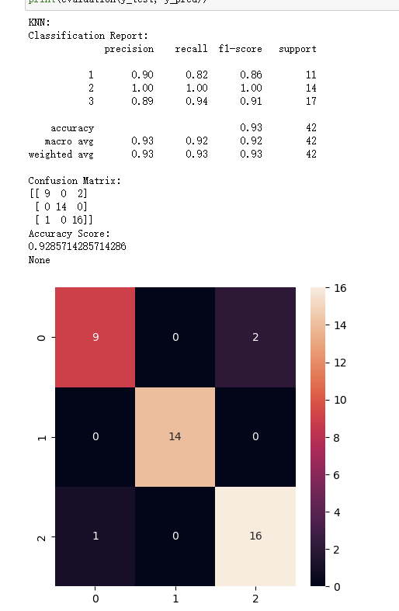
Matched Logistic Regression's accuracy at 93%
Excellent performance for class 2 (Kama wheat)
Good balance between precision and recall for all classes
Minor confusion between classes 1 and 3
(4)Naive Bayes
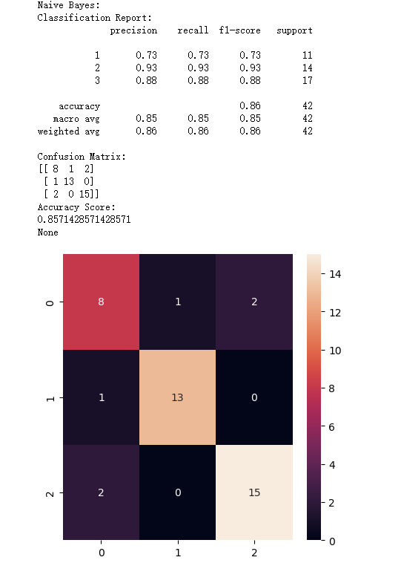
Achieved an accuracy of 86%
Lower performance compared to other algorithms
More balanced but lower precision and recall scores across classes
Higher number of misclassifications between classes

(5)Support Vector Machines (SVM)
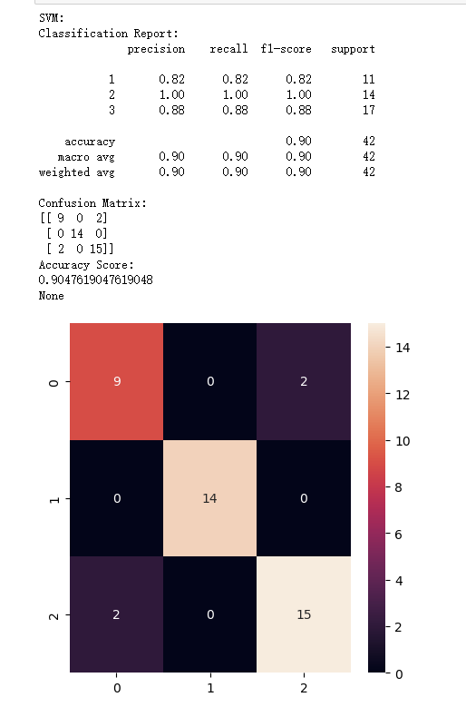
Attained an accuracy of 90%
Strong performance for class 2 (Kama wheat)
Good overall balance between precision and recall
Some confusion between classes 1 and 3

(6)Decision Tree
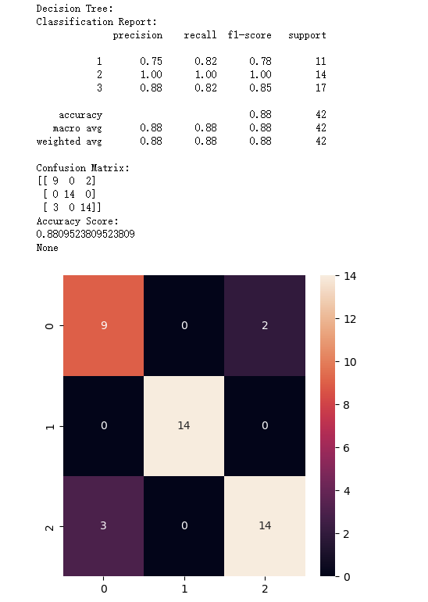
Achieved an accuracy of 88%
Good performance for class 2 (Kama wheat)
Balanced performance across classes
Moderate confusion between classes 1 and

3. Discussion and Conclusions
1. Challenges and Solutions
1.1Data Preprocessing Issues
The wheat dataset presented several preprocessing challenges:
Feature Scaling:
Challenge: Different features had varying scales
Solution: Implemented standardization to normalize all features
Outcome: Improved model performance and convergence
Class Imbalance:
Challenge: Slight imbalance in wheat variety distribution
Solution: Used stratified sampling in train-test split
Outcome: Maintained balanced evaluation metrics across classes
2.Parameter Design
2.1SVM Parameters:
Determining the appropriate kernel and gamma value. Started with default parameters and gradually adjusted based on performance. Found that the default 'auto' gamma setting provided satisfactory results
3. Key Learnings
3.1 Algorithm Selection Insights
The experiments revealed important considerations for algorithm selection:
Classification Tasks:
Logistic Regression and KNN showed robust performance
Naive Bayes performed better than expected on certain features
SVM required careful parameter tuning for optimal results
Clustering Tasks:
DBSCAN's superiority in handling non-convex clusters
K-means' efficiency with well-separated data
NMF's effectiveness in feature extraction and dimensionality reduction
3.2 Practical Implementation
1. Data Understanding:
Importance of thorough data exploration before modeling
Feature relationships and their impact on algorithm performance
Data distribution characteristics and their influence on model selection
2. Model Evaluation:
Need for multiple evaluation metrics
Importance of cross-validation
Visualization's role in understanding results
3. Parameter Optimization:
Systematic approach to parameter tuning
Balance between model complexity and performance
Importance of domain knowledge in parameter selection

Appendix
Appendix A:Database
seeds_dataset.txt
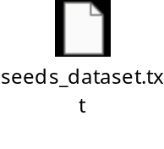
Appendix B:Experimental code
exp2_LuJiawei_2023280113.ipynb
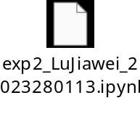
深圳大学学生实验报告用纸

指导教师批阅意见：

成绩评定：

指导教师签字：
年 月 日
备注：
注：1、报告内的项目或内容设置，可根据实际情况加以调整和补充。
2、教师批改学生实验报告时间应在学生提交实验报告时间后10日内。

